EXPT. NO: 7 | LOOPING CONSTRUCTS
DATE:8.1.2020 | LOOPING CONSTRUCTS
Aim:
To write a C program for the following
- To find the sum and average of N numbers
- Check whether the given number is Armstrong or not
1. To find the sum and average of N numbers
Algorithm
- Start the program
- Initialize Sum And I = 0
- Read the values of n
- FOR i=0 i < n i++, then go to step 5 and 6 other wise go ot step 7
- GET The Value Of a[i]
- Compute sum = sum + a[i]
- Computer avg=sum/n
- Print The Value Of Avg And Sum
- Stop the program

Flowchart
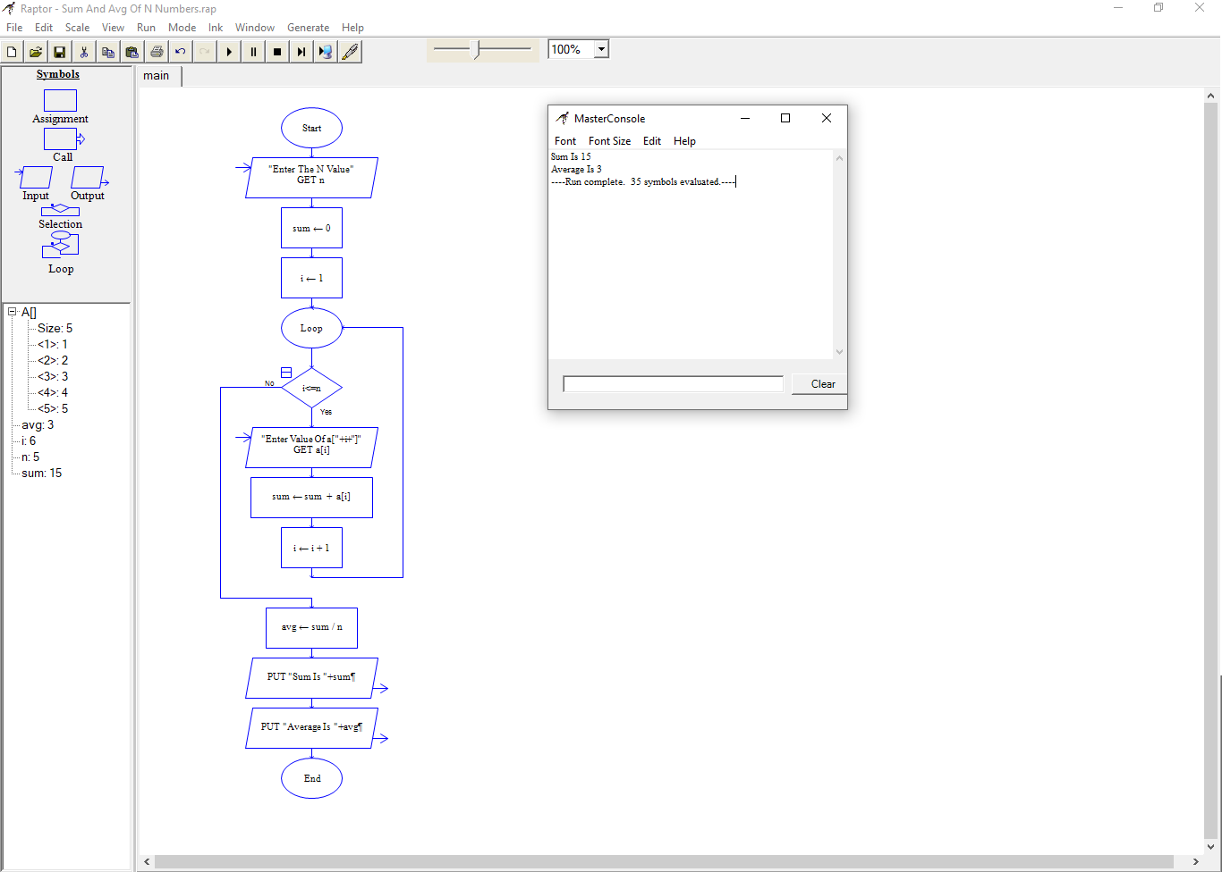
Program
#include<stdio.h>
int main() {
int i,n,Sum=0,numbers;
float Average;
printf("\nPlease Enter How many Number you want?\n");
scanf("%d",&n);
printf("\nPlease Enter the elements one by one\n");
for(i=0;i<n;++i) {
scanf("%d",&numbers);
Sum = Sum +numbers;
}
Average = Sum/n;
printf("\nSum of the %d Numbers = %d",n, Sum);
printf("\nAverage of the %d Numbers = %.2f",n, Average);
return 0;
}
Output
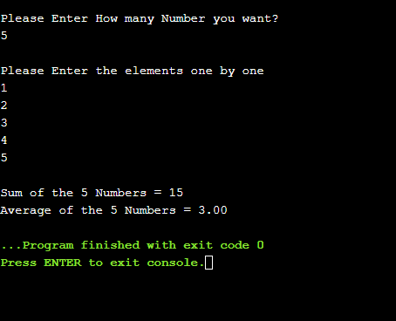

2. Check whether the given number is Armstrong or not
Algorithm
- Start the program
- Initialize Sum
- Read the values of num
- FOR temp=num num != 0 num=num/10, then go to step 5 and 6 other wise go ot step 7
- Compute r = num % 10
- Compute sum = sum+(r*r*r)
- IF sum == temp go to step 8 otherwise go to the step 9
- Print The Value Of “temp is an Armstrong number.”
- Print The Value Of “temp is not an Armstrong number.”
- Stop the program

Flowchart
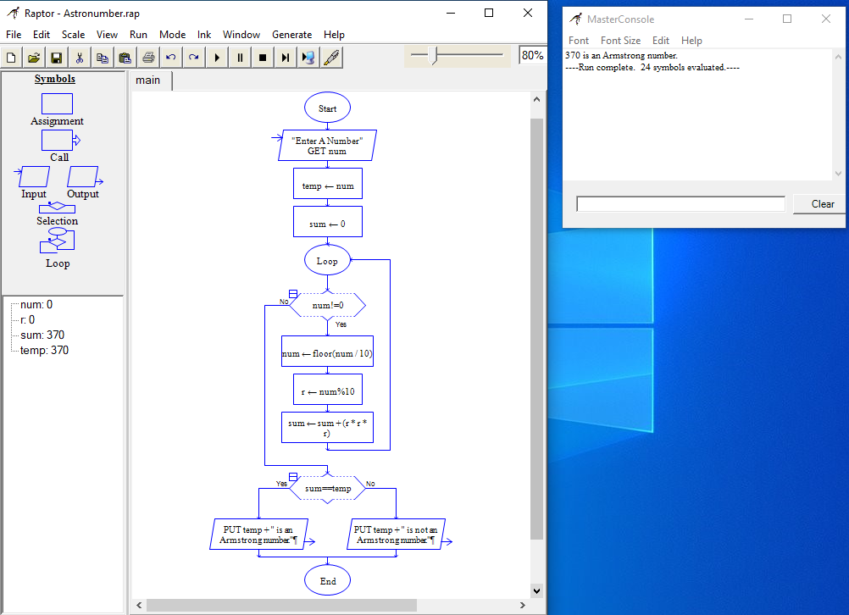
Program
#include <stdio.h>
int main() {
int num,r,sum=0,temp;
printf("Enter A Number: ");
scanf("%d",&num);
for(temp=num;num!=0;num=num/10){
r=num % 10;
sum=sum+(r*r*r);
}
if(sum==temp) {
printf("%d is an Armstrong number.\n",temp);
} else {
printf("%d is not an Armstrong number.\n",temp);
}
return 0;
}
Output
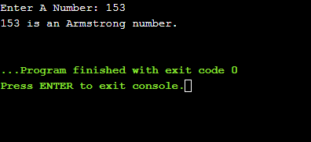

Result
Thus the C program was written and executed successfully for the following
- To find the sum and average of N numbers
- Check whether the given number is Armstrong or not

